# Wind Turbine Lab Report

Submitted to:  
Professor Jayakumar  
Ben Richetti

Created by:  
Group G

Michael Chiou  
Lucky Katneni  
Bella Scholtes

Engineering 1181  
The Ohio State University  
Columbus, OH  
26 March, 2021

## **Executive Summary**

The problem presented to team G was to find out what type of wind turbine would satisfy the energy requirement of a residential complex of 40 houses in Lakeside Marblehead, Ohio. The team conducted an experiment to determine what type of wind turbine would yield a greater power output. In this lab, an apparatus was set up to measure the power output generated by wind speed. By looking at different variables of the wind turbine and how those individual factors affected the amount of power, the team was able to identify the most effective design model. Individual factors include number of blades (2, 3, 6), blade shape (rectangular, wedge, lead, and balloon), blade pitch angle (30° and 45°), and blade material (plastic or wooden).

The team used Bernoulli’s Principle, which states that as velocity of a fluid increases, the pressure exerted by that fluid decreases. This concept relates the difference in pressure to wind speed which affects the performance of wind turbine blade designs. The results of this lab will be used to determine the blade design, blade shape, and blade quantity which will lead to the greatest power-producing wind turbine. This optimal combination will be put to use in the residential complex to provide power to the 40 houses in Lakeside Marblehead.

Upon examining the results of the LED neighborhood experiment, the 4 plastic molded blades produced the greatest power output when compared to the 3 plastic molded blades and the 6 wooden balloon-shaped blades. The team found that an optimal quantity of blades such as the 3 or 4 bladed propellers produced a greater power output than both the propellers with less blades, such as the 2 bladed propellers, and the propellers with more blades, such the 6 bladed propellers, tested in this lab. The team observed that there exists a correlation between a greater wind speed and a greater power output generated by the wind turbines. The team found that the balloon-shaped blade yields higher output when compared to the other designs the team made. Similarly, based on the experiment’s results, it can be concluded that the three bladed wind turbine and the 30° pitch angle is optimal as it generated more output.

The experiment done was not completely perfect as there were some errors. Not all the replicated blades had the exact same shape as they were needed to the carved using a knife, and the team was lacking in knife skills. One solution to this is to laser cut the wooden blades to eliminate human error. The next error is that the data recorded in myDAQ was fluctuating very frequently which made the team estimate an average value. One better way of recording the data could be to programmatically calculate the mean of the values. Another error occurred due to the fact that the balsa wood was not completely thin and smooth, which caused some air resistance which was not taken into the account while calculating the power output. One recommendation to yield better results is to make the blades thinner and smoother before starting the experiment.

Based on the results of the procedure, the team recommends a wind turbine with three balloon-shaped blades for the design of this turbine. Since the turbine is to be placed on Lakeside Marblehead, Ohio where the average wind speed is 6.82m/s, which is high for Ohio, 3 blades and the balloon design would produce a large power output with little interference from nearby buildings. The team also recommends plastic-molded blades with a 30° pitch angle to produce the greatest power output to the residential complex. This recommended wind turbine design would produce around 5,553.624 KWH, which is more than two times the power needed for the residential complex.

Table of Contents

1. Introduction.................................................................................................... 4
2. Experimental Methodology............................................................................ 5-6
3. Results............................................................................................................ 7-9
4. Discussion...................................................................................................... 10-11
5. Conclusions & Recommendations................................................................. 12

References........................................................................................................... 13

APPENDIX A

Tables, Graphs, and Figures

APPENDIX B

Equations and Calculations

APPENDIX C

Symbols

**Introduction**

This lab report is prefaced with an executive summary which will give a brief overview of the experiment done by the team. Then, the table of contents section is provided which provides where the specific contents of the lab report can be located. The apparatus, lab conditions, and the procedures done in the lab is described in the Experimental Methodology section. The Results section presents the observations and the data found in the Experimental Methodology section, and the Discussion section provides an analysis of the data presented in the results section and compares the data with the expected data based on theory. The final conclusion and recommendations are given in the Conclusion and Recommendations section.

The widespread adoption of wind power to generate electricity has become prevalent in the wind power industry as a source of cheap and renewable energy. Through wind power, mechanical energy is converted to electricity through the rotation of turbine blades.

The purpose of this lab experiment is to examine the effect of varying quantities of blades, blade material, blade shapes, and blade angles on the power output of a wind turbine for the purpose of supplying power to a residential complex.

Using the knowledge obtained prior to the experiment regarding Bernoulli’s equation and fluid mechanics, the members of Team G proposed different designs of wind turbine blades that were later tested in separate trials. The trial data was then used to determine which individual blade design features produced the most power by drawing conclusions from the data.

The team then tested four different blade quantities, 2, 3, 4, and 6 blades, along with different blade angles, 30° and 45°. All tests were conducted with equal voltage outputs ranging from 6 V to 12 V to ensure that all power outputs were evaluated equally.

The team determined that the power output of wind turbines is largely determined by the size, shape, and angle of the turbine blades, in which the most efficient combination is discussed in the Discussion section.

The team then decided on an optimal location for the placement of the wind turbine, which had to be an area with high wind-speeds, minimized building interference, and a low population density to prevent noise disturbances.

In this study, the engineers in Team G use the data collected to estimate how much energy a single wind turbine in Marblehead, OH could supply to a residential complex with 40 houses, each of which consume around 50 KWH per day. The estimate was determined using a 77 m diameter turbine with 32 m blades with a 25% turbine efficiency as a model to determine how much power the turbine can supply to the residential neighborhood.

## **Experimental Methodology**

There are four specific steps of the experiment which need to be completed in order to effectively conduct this Wind Turbine Lab experiment. These steps include the following: setup, building a wind turbine set, testing the power produced by the wind turbine with varying number of blades, and using an alternative method to test the power produced by the wind turbine through an LED neighborhood.

Step 1: Setup

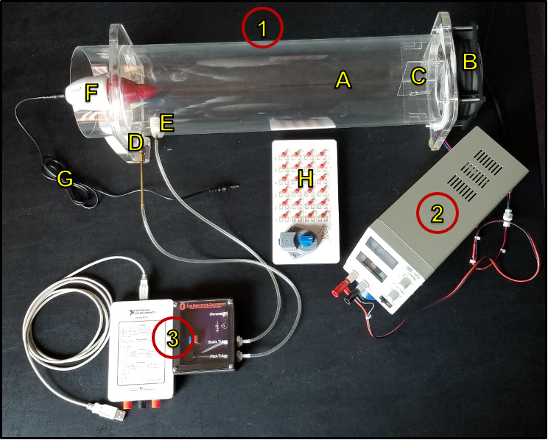

Figure 1. The Wind Turbine Apparatus

The wind turbine apparatus used in this experiment consists of the following: a wind tunnel flow tube (A), a wind source fan (B), flow straightener vanes in positive orientation (C), a pitot tube (D), a static tube (E), a wind turbine (F), a wind turbine power cable (G), and an LED neighborhood (H). All of these components should be connected as shown in the figure above. The power cable should be connected from the variable power supply to the wind tunnel source fan and the cables should be connected with cables of the same color. On the variable power supply, there is the Voltage (CV) knob that will be used to adjust the amount of power given to the source fan and the Current (CC) knob. The hose from the pitot tube should be connected to the hose barb connector on the Pitot Tube breakout board. The hose from the static tube is to be connected to the hose barb connector on the Static Tube breakout board. The MyDAQ should be plugged into a USB port on a computer, which opens the ELVISmx instruments launcher window used to record data. Wait 5 minutes then press the *Set Zero* button in order to see the change in voltage relative to that point.

This application will take the Root Mean Square Value of the differential pressure signal as a small noise reduction before calculating wind speed. The source fan in the experiment has a maximum voltage rating of 12 Volts, so all measurements taken in this experiment will also be conducted using 12 Volts. After all connections are made, the variable power supply can be turned on and the experiment can begin.

Step 2: Designing the wind turbine blade set

Each team member proposes a specific design for the blade and carves out the blades using thin balsa wood. They then carve the blade on a cutting board. The designs the team made are shown below:

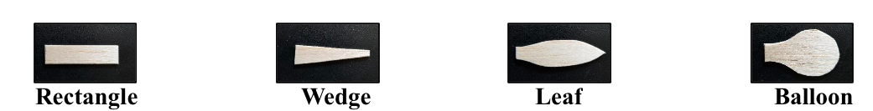

Figure 2. The four different designs of wind turbines. (from left to right: Rectangular Shape, Wedge Shape, Leaf Shape, and Balloon Shape)

The team tests each of the blade designs at 12V input by inserting one blade into the 30° pitch prob hub and the 45° pitch prob hub separately and then recording the power output shown in Table 1 of appendix A. The blade design which produced the highest output is chosen for testing the optimal number of blades for the turbine in the next step.

Step 3: Test the power produced by the wind turbine while varying the number of blades

Using the wind turbine blade set, selected in the previous step, create an outline of it to make 5 identical balsa wood turbine sets. A blade is placed in the opposite slots with the 30° hub and the power produced should be recorded as shown in Table 2. In Table 3 on the lab data sheet, record the power output and wind speed of the two blades with voltages between 6V to 12V. This process is then repeated for 3 blades and 6 blades to complete Table 3.

Select the wind turbine that produces the most power output in Table 2, and transfer the selected arrangement onto the blue prop hub with the 45° pitch. Test this 45° pitch prob hub and record the power output in Table 4.

Step 4: An alternative way to test the power that is generated by the wind turbine

The plastic molded propellers generate more voltage than the myDaq can handle so the power output is measured with a digital multimeter. A 3-bladed plastic propeller and a 4-bladed plastic propeller are tested at 12 Volts. Next, plug the audio cable that was originally plugged into the breakout board into the input port on the LED neighborhood. Using the 6-blade wooden propeller, run the power at 12V and continually turn the dial on the LED neighborhood until the maximum number of rows of LEDs can be fully lit up. If adding a row causes the rest of the lights to dim, then this indicates that there is not enough power produced from the turbine to power another full row of LEDs. Repeat this step for the 3-bladed plastic propeller and the 4-blade plastic propeller.

## **Results**

In step 2, each team member proposed different blade designs and carved out the blades using balsa wood. The blade designs were the following: balloon, wedge, leaf, and rectangle. Then, each design was tested by inserting each blade into a 30° pitch hub with a fan across the wind tube with a power input of 12V. The data was recorded into the Table 1 using the power output (in watts) from MYDAQ. From the data, it is observed that the balloon-shaped blade produced the highest power output at 3.03 watts, surpassing the power output of the three other blade shape designs.

Further testing was performed on the balloon-shaped blade designs in step 3. In both of these tests, the balloon-shaped blades were attached to a 30° pitch hub and tested against a 12V power supply. The first tested the effect of the number of blades on the power output of the wind turbine in separate trials of 2, 3, and then 6 blades. The 2-bladed design produced a power output of 4.18 watts, the 3-bladed design produced 4.38 watts, and the 6-bladed design produced 4.40 watts. These results are shown in Table 2 and represented in Graph 1. From these recorded observations, the 3-bladed design has the highest power output at 4.38 watts.

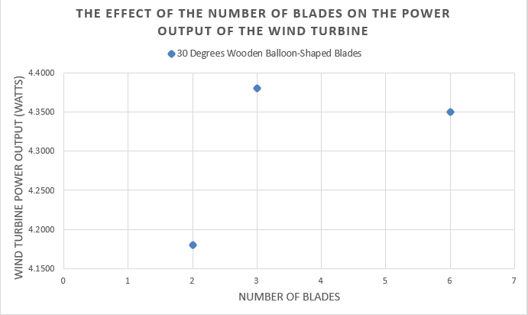

Graph 1: Power output of the wind turbine with different number of blades

In the next test, three trials were performed with a varying number of blades (2, 3, then 6) to test the effect of the number of blades on the wind velocity (m/s) and power output (watts) of the wind turbine. In these trials, the power supply voltage was increased starting from 6V to 12V. The wind velocity and power output were then recorded at each whole-number voltage reading for a total of 6 data recordings for the wind speed and 6 data recordings for the power output for each trial. These data recordings are shown in Table 3 represented in Graph 2. From Table 3, the 3-bladed wind turbine design in general had the greatest wind speed and power output for each voltage reading among the other trials. From Graph 2, the voltages are omitted, showing a strong relationship between wind velocity and the wind turbine power output.

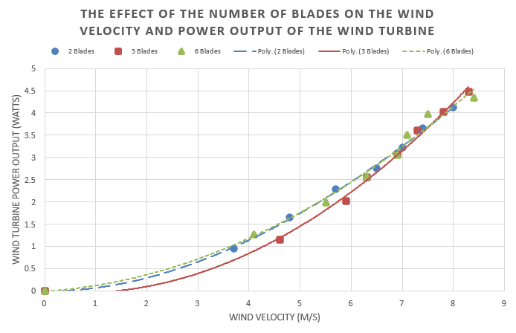Graph 2: The power output under and wind velocity for 2 blades, 3 blades, and 6 blades

Then, in step 4, the team tested 3-bladed and 4-bladed plastic molded propellers at 12V on the power supply. Since the propellers generated more voltage than the myDAQ could handle, their power output was measured with the digital multimeter instead. The 3-blade plastic propeller had a voltage output of 10.49V while the 4-bladed plastic propeller had voltage output of 13V. After testing these propellers, the team then tested the 3-bladed and 4-bladed plastic molded propellers against the 6-bladed wooden balloon design using an LED neighborhood. The idea behind this test is that the propeller producing greatest power output would light up the greatest number of rows of LEDs in the LED neighborhood.

First, the 6-bladed wooden balloon propellers were tested, in which 4 rows of LEDs were fully lit up. Next, the 3-bladed plastic propellers were tested, in which 5 rows of LEDs were fully lit up. However, when tested on the 6th row of LEDs, the rest of the LEDs dimmed. This indicates that there was not enough power output to fully power the 6th row of LEDs without drawing power from the rest of the rows. Finally, the 4-bladed plastic propellers were tested, in which all 6 rows of LEDs were fully lit up. Therefore, the 4-bladed plastic propellers produced the greatest power output compared to the 3-bladed plastic propellers and the 6-bladed wooden balloon propellers.

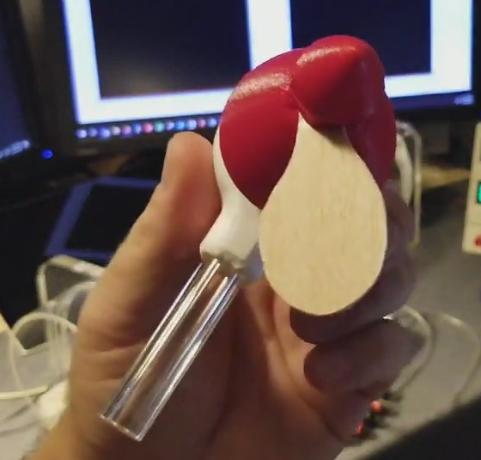

Figure 3. Balloon Shape Design

## **Discussion**

The number of blades is important when it comes to the wind turbine design. The blade count influences the price, weight, and efficiency of the wind turbine. As the number of blades increases, the price of manufacturing increases along with the weight of the turbine. Furthermore, the efficiency of the wind turbine is seen to decrease as more blades are added onto the propeller beyond 3 or 4 blades. In step 4 of the results, the team found that 4-bladed molded plastic designs produced the highest power output when compared to the 3-bladed molded plastic and 6-bladed wooden balloon designs.

Graph 1 illustrates the effect that the number of blades on a wind turbine has on the power output of the wind turbine. According to the plotted points, an increase in the number of blades will also increase the power output. However, the 6-bladed wind turbine’s power output was shown to be lower than the 3-bladed wind turbine's power output. This result leads the team to believe that the weight of the blades plays a role in the efficiency of the wind turbines. This could also be due to the fact that 6 blades are heavier than 3 or 4 blades so those extra blades would slow down the wind turbine and cause less power output to be produced.

Derived from the experiments in Step 2 and Step 3, Graph 2 reiterates that the 3-blade structure produces the most amount of power. When it comes to blade shape and configuration, engineers must design a blade that has the right amount of rotor blade lift and thrust in order to improve the efficiency of the blades. If the material is too heavy, the blades may rotate too slow and not produce enough output. If they rotate too quickly, a good amount of drag is produced, causing the blades to barely rotate. Finding the perfect tradeoff between materials, tilt, angle, and configuration is often hard to acquire.

Even though the data collected by the team largely “make sense,” some potential errors may have occurred during the experiment. To begin with, the blade designs were cut using knives, which brings the possibility of human error in the inconsistency of the blade shapes as the surface area of the replicated blades may slightly differ from one other. One possible solution to this is to draw the shapes on a sheet of paper, cutting them into pieces, and pressing them on the wood to use as an outline while cutting. Another possible solution is to laser-cut the wooden pieces to eliminate the human error from cutting the pieces. These solutions ensure that the blades have a more consistent shape and surface area between all of the blades.

Another possible source of error could be the fact that the air resistance which the balsa wood produces while rotating is not taken into the account. The air resistance could cause the actual power output to be less than the power output displayed by myDAQ. This would be a systematic error because the values are precise, but not accurate as they were lesser than the actual values. This air resistance systematic error could be decreased by sanding the surface of the wooden blades to create a slimmer blade profile.

While recording the data from the myDAQ, the team observed that the values shown in the myDAQ fluctuated very frequently which forced the team to take a rough estimate of the average value instead of a precise, computer-calculated average value. This is a human error. One possible solution to this problem could be to watch the video in 0.25x speed, and taking random value readings to record and then average using a calculator.

In Lakeside Marblehead, OH, a residential complex is interested in using wind energy to supply their 40 houses. The horizontal axis wind turbine has a height of 80 m and a blade length of 32 m, with a rotating diameter of 77 m on a circular path. To calculate the available wind power to support the average wind speed of 6.82 m/s in Lakeside Marblehead, Equation 1 can be used. This equation measures the area that the turbine reaches by subtracting the area that the blade does not reach. The residential complex with 40 houses requires 50 KWH/day per house meaning the total power of the neighborhood requires 2,000 KWH/day. By inserting the calculated area, using Equation 1 and the values for velocity and air density into Bernoulli’s equation, the dimensions of the wind turbine show that the available wind power is about 925.604 KW, calculated using Equation 2. However, because the wind turbine is 25% effective, the power received is only 231.401 KW. According to the energy calculations below in equation 3, the amount of energy the wind turbine produces in a day is 5,553.624 KWH, found using Equation 3. The entire residential complex can be powered by this turbine alone, as the supply of energy from the wind turbine outlies the energy needed for the complex which is 2000 KWH.

**Conclusion & Recommendations**

The wind turbine lab allowed the engineers on Team G to maximize the amount of power output by testing different variables of wind turbines. To begin with, the team has set up the apparatus as shown in the figure 1. Then, each member proposed a blade design, and all the blade designs were made using balsa wood, and they were all tested individually at 12V, by inserting one blade into the propeller pitch at 30° angle and recorded the output generated using MYDAQ. Then the team concluded that the balloon design is the most efficient one as it generated the output of 3.03V as it is the highest when compared to others. Then, the team has replicated the balloon design 5 times and made six blades of the balloon shape. Then the team tested the power output with different number of blades at different voltages starting from 6V to 12V increasing incrementally to select the most efficient one. The team has recorded the power outputs of for 2-blade, 3-blade, and the 6-blades in the table 2. It is concluded through experiments that the 3-blade turbines output the great amount of power than the 2-blade and 6-blade models. Then the team has changed the propeller pitch angle to 45° keeping the other variables constant. Then the team has tested the power output for 45° and recorded the power output at 12V for both 30° and 45° angle in table 3. The team found out that the 30° pitch angle produced an output of 4.48V which is nearly 2.5 times more than the power output when the angle was 45°. It is then concluded that the turbine outputs more power with 30° pitch angle than with 45° pitch angle.

While the experiment was successful, some potential errors in the experiment were identified. The blade design models pose as an error due to the precision of cutting them out using knifes. This creates inconsistency and has the opportunity to corrupt the data collected with a faulty replica. To combat this error, the models are suggested to be cut out prior to the experiment on a piece of paper, the traced onto the wood when making the design selection. This would not only be a proficient way to save time in the experiment, but would minimize precision errors in the model replications. A potential systematic error that was observed during this experiment was the texture of the balsawood, the material of the turbine blades in the lab. The texture of the balsawood creates friction, friction that is not accounted while the blade is rotating in the experiment. In order to create more accurate data and minimize the amount of friction acting against the blade, the team recommends smoothing out the blades before the power output of the blades is measured. Due to the speed of which the data values shown in the MYDAQ fluctuates, the team found it difficult to read the power outputs displayed. This led the team to taking the average value of the displayed values rather than a more precise estimate. A solution to this systematic error could be to view the experimental video in 0.25x speed or frequently pausing the video and recording the values on the monitor.

**References**

1. Course materials, SP21 ENGR 1181.01 - Fund Engr 1 (9777), Modules, Lab 08 Wind

Turbine Lab, Before Class, preparation material - PDF

2. Course materials, SP21 ENGR 1181.01 - Fund Engr 1 (9777), Modules, Lab 08 Wind

Turbine Lab, Lab Procedure – PPTX

<https://osu.app.box.com/s/a6i6s3ik9olqvp4s1nhd8xjkoun0dg8h>

3. “Optimizing the NW off-shore wind turbine design”, *Elsevier,*

<https://osu.app.box.com/s/llsvs91x8b8osjcdqojafg20pzc4tz5j>

4. DataBuckeyebox.(n.d.) Wind Turbine Lab Datasheet. Retrieved March 12th, 2021 from

<https://osu.app.box.com/s/63461hd3tmcp6sljis6sl2gx9w9fjvj4>

**APPENDIX A**

**Tables, Graphs, and Figures**

**Table 1: Wind Power Output vs Blade Shape**

|  |  |  |
| --- | --- | --- |
| **Blade Design No.** | **Single Blade Power Output (watts)** | **Blade Shape**  **Description** |
| **1** | 2.8000 | Rectangle |
| **2** | 0.7600 | Wedge |
| **3** | 2.3600 | Leaf |
| **4** | 3.0300 | Balloon |

**Table 2: Calculated Wind Power vs Power Output**

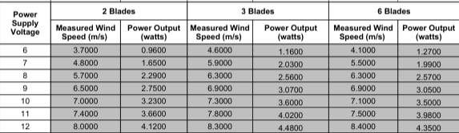

**Table 3: Wind Power Output vs Propeller Pitch**

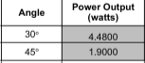

**Table 4: Number of Plastic Blades vs Voltage Output**

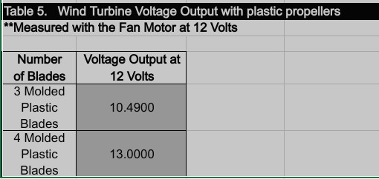

**Graph 1: Power output of the wind turbine with different number of blades**



**Graph 2: The power output and wind velocity vs 2 blades, 3 blades, and 6 blades**



**Figure 1: The Wind Turbine Apparatus**



**Figure 2: The Four Different Blade Designs**



**Figure 3: The Balloon Shape Design**



**Figure 4: Chart showing wind speed in Lakeside Marblehead, OH**

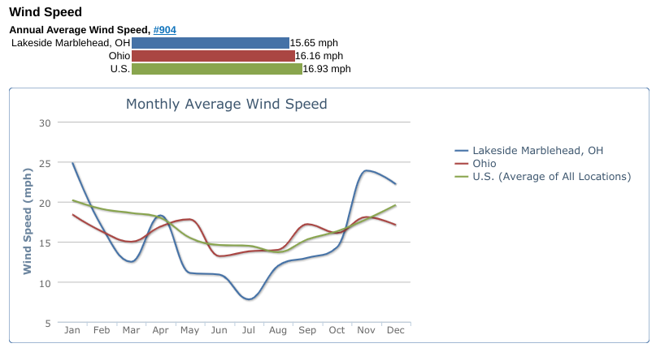

**APPENDIX B**

**Equations and Calculations**

Area Total area = A = (π * (R)^2) [Equation 1]

Area of the nose cone of the turbine = (π * (r)^2)

A = (π * (R)^2) - (π * (r)^2) = 4523.9 m^2

Power P = ½ * p * A * v^3 [Equation 2]

Energy E = (P x t)/1000 [Equation 3]

**APPENDIX C**

**Symbols**

A = Area swept by blades

A = Total area – Area of the nose cone of the turbine

D = Diameter of total area

R = Radius of total area = (D / 2)

d = Diameter of the nose cone of the turbine

r = Radius of the nose cone of the turbine

P = Power generated by the wind turbine

E = Energy generated by the wind turbine